# load dataset

mydata<-read.csv(file.choose())

mydata

head(mydata)

str(mydata)

mydata$Company<-as.factor(mydata$Company)

mydata$Product<-as.factor(mydata$Product)

mydata$TypeName<-as.factor(mydata$TypeName)

mydata$ScreenResolution<-as.factor(mydata$ScreenResolution)

mydata$Cpu<-as.factor(mydata$Cpu)

mydata$Ram<-as.factor(mydata$Ram)

mydata$Memory<-as.factor(mydata$Memory)

mydata$Gpu<-as.factor(mydata$Gpu)

mydata$OpSys<-as.factor(mydata$OpSys)

mydata$Weight<-as.factor(mydata$Weight)

str(mydata)

mean(is.na(mydata))

#install required packages

install.packages("ggplot2")

library(ggplot2)

ggplot(mydata, aes(x=Company, y=Price_euros)) +

geom_boxplot(fill="blue")

#A boxplot of companies

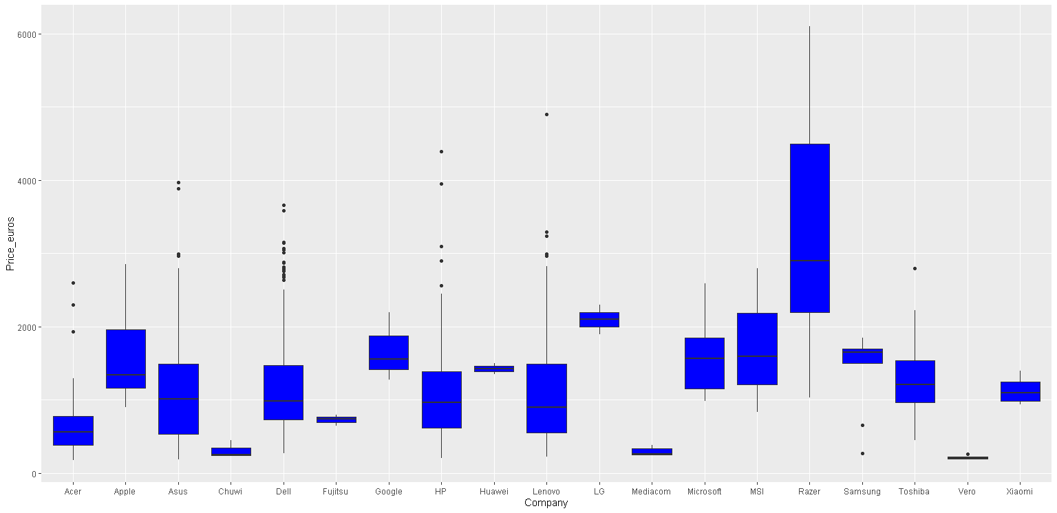

ggplot(mydata, aes(x=TypeName, y=Price_euros)) +

geom_boxplot(fill="red")+ggtitle("A boxplot comparing typename and price_euros")

#A boxplot of typename

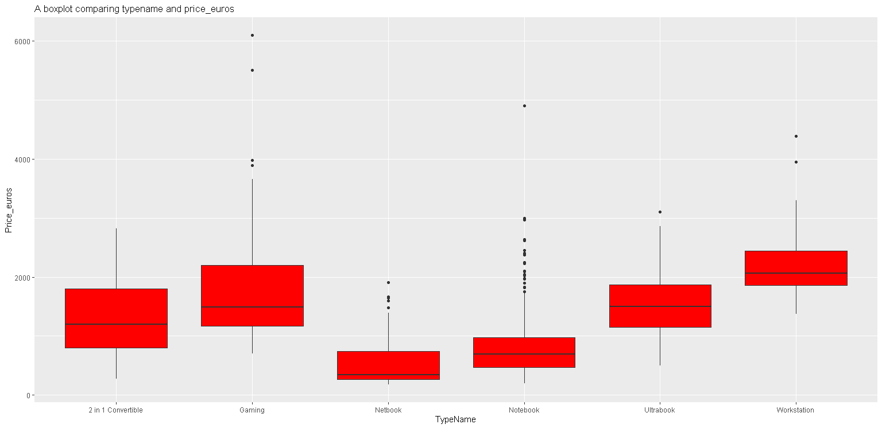

ggplot(mydata, aes(x=OpSys, y=Price_euros)) +

geom_boxplot(fill="red")+ggtitle("A boxplot comparing opsys and price_euros")

#A boxplot of operating systems

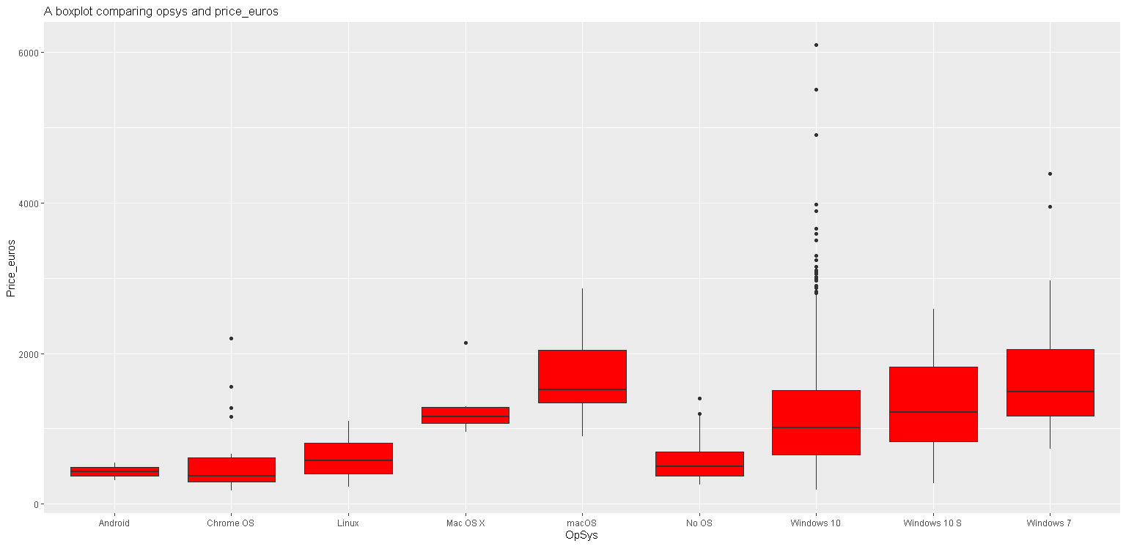

ggplot(mydata, aes(x=Ram, y=Price_euros)) +

geom_boxplot(fill="red")

#A boxplot of ram

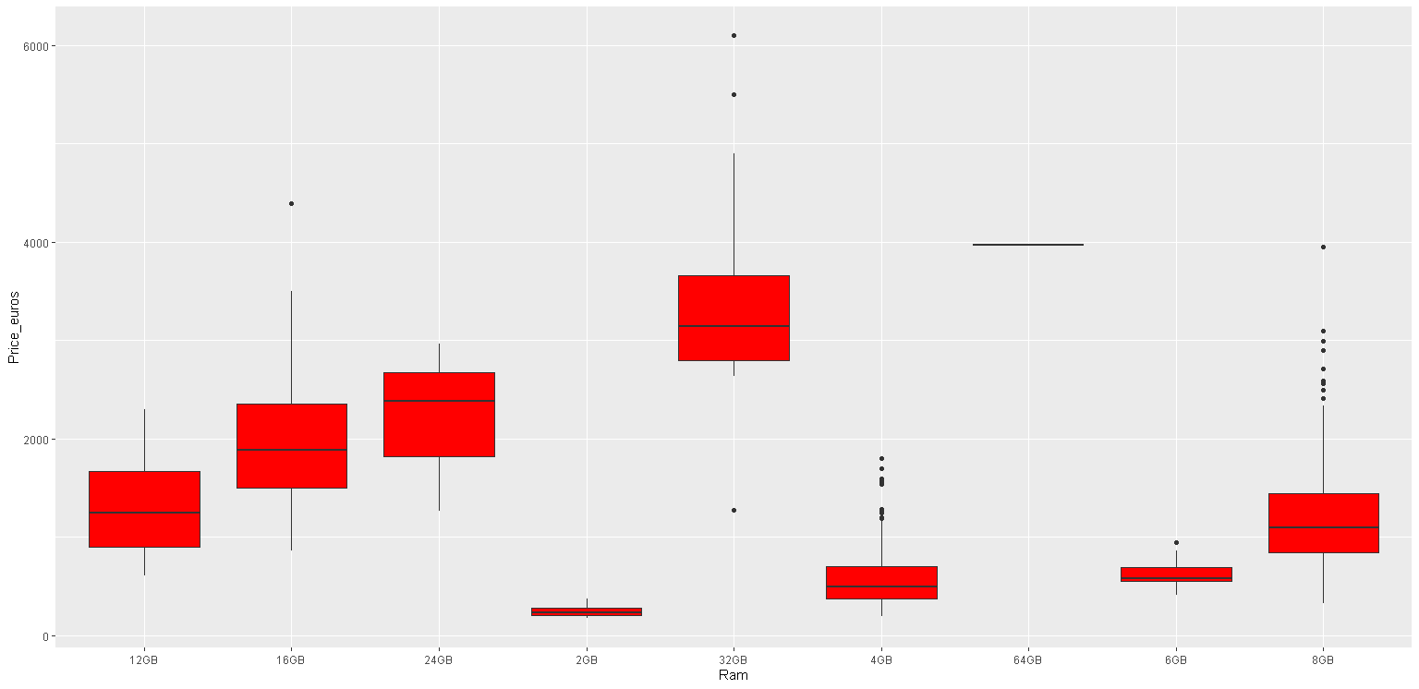

ggplot(mydata,aes(Price_euros))+geom_histogram(fill="red")

#A histogram of price of laptops

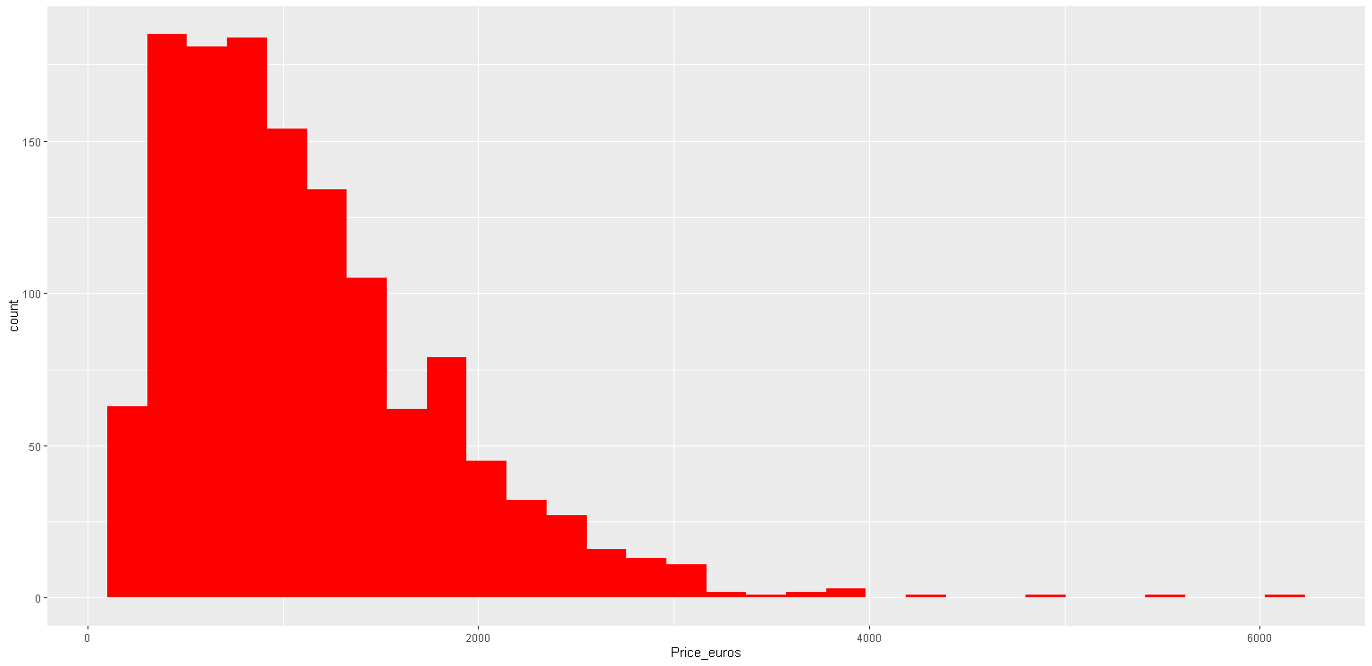

ggplot(mydata,aes(x=Company,fill=Memory))+geom_bar(position = "dodge")

#A bargraph of companies filled with memory

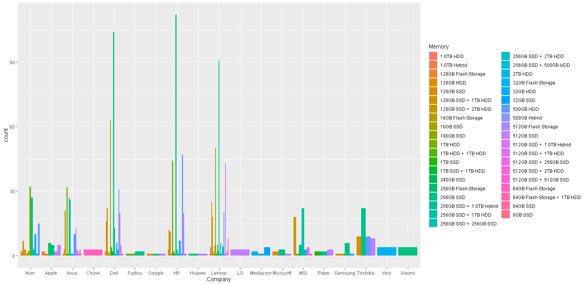

ggplot(mydata,aes(x=Company,fill=OpSys))+geom_bar(position = "dodge")

# a bargraph of companies filled with operating system

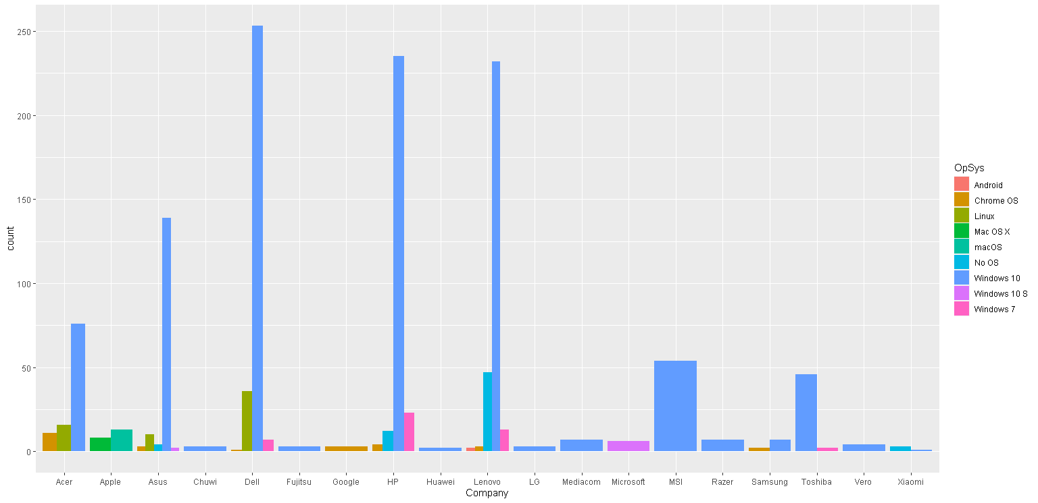

ggplot(mydata,aes(x=TypeName,fill=OpSys))+geom_bar(position = "dodge")

# a bargraph of typename filled with operating system

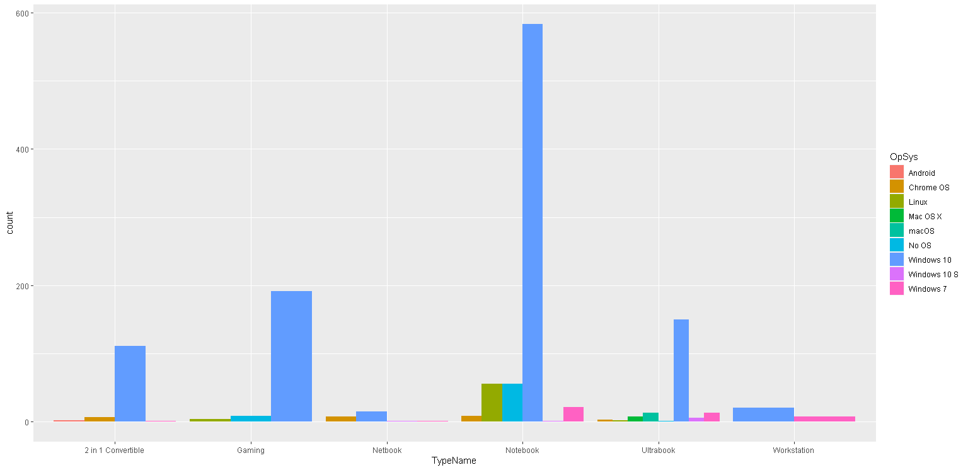

ggplot(mydata,aes(x=OpSys,fill=TypeName))+geom_bar(position = "dodge")

# a bargraph of operating system filled with typename

